**MULTI VARIABLE REGRESSION**

This algorithm is used to predict the out of a third variable knowing two or more variables. If there are just two independent variables, the estimated regression function is 𝑓(𝑥₁, 𝑥₂) = 𝑏₀ + 𝑏₁𝑥₁ + 𝑏₂𝑥₂. It represents a regression plane in a three-dimensional space. The goal of regression is to determine the values of the weights 𝑏₀, 𝑏₁, and 𝑏₂ such that this plane is as close as possible to the actual responses and yield the minimal SSR.

The case of more than two independent variables is similar, but more general. The estimated regression function is 𝑓(𝑥₁, …, 𝑥ᵣ) = 𝑏₀ + 𝑏₁𝑥₁ + ⋯ +𝑏ᵣ𝑥ᵣ, and there are 𝑟 + 1 weights to be determined when the number of inputs is 𝑟.

Using a stock index price versus (Unemployment_rate and interes_rate) the values of these rate were used in the formula to predict the stock index price.

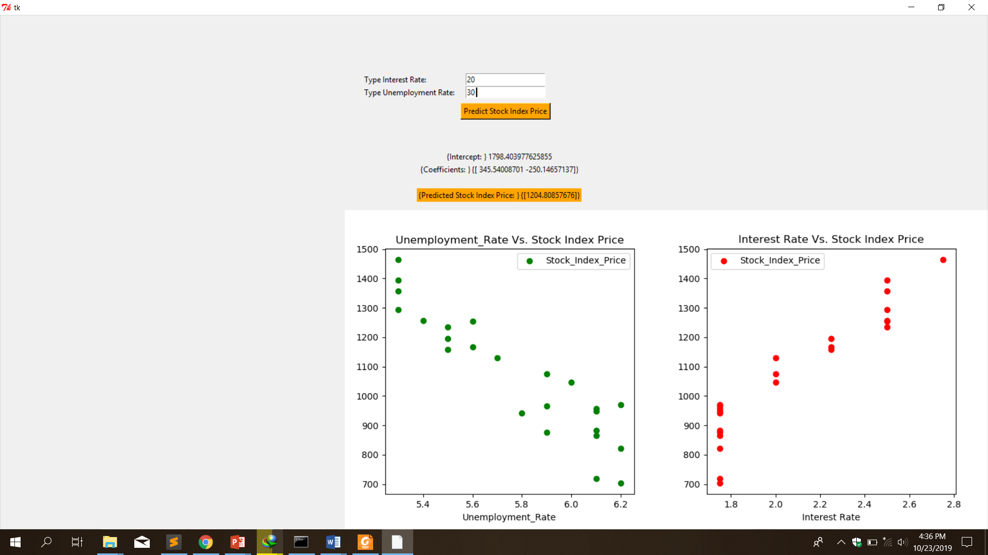

Entering the values of unemployment rate and interest rate, the value of the stock index price is predicted.

